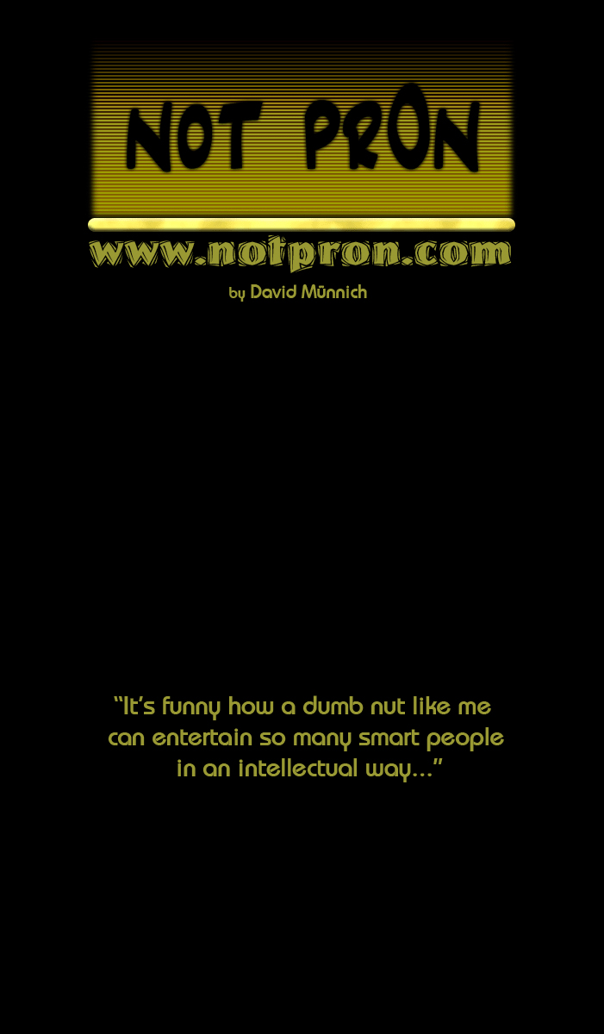


Behind the scenes, by David Münnich - Version 1 (1. Mar. 2005)
http://www.notpron.com

1. Introduction | If you are new to the riddle, only read this for the start! | Page 3
2. Development and Stories | How and why it was made. Development including problems and outtakes of all levels. Funny mistakes and comments. Including countless pictures!  (Page numbers equal Level numbers in most cases) | Page  4
3. Riddle Design Guide | How to make your own riddle? Some guidelines here. Including some “how not to do it” examples! | Page  13
4. Quotes | Stupid/entertaining quotes from riddlers! | Page  14
5. Thanks to... | People who I need to thank for their help! | Page  15
6. Walkthrough | The correct interpretations of all hints, all Easter eggs discovered, all riddles solved! | Page  16

All rights reserved; no part of this publication may be reproduced or transmitted by any means, electronic, mechanical, photocopying or otherwise, without the prior permission of the publisher

First published in Germany in 2005

Copyright © 2005 by David Münnich

1. Introduction – People who haven’t played the riddle yet, read this part, for an introduction of what it is and how to have weeks of fun with it!

Why am I writing this? What is this about? Oh my god, where am I? Mom?
Ok, “notpron” as we usually just call it is an unexpectedly popular online riddle I designed. It currently (Feb. 2005) consists of 99 levels. Some more, some less
challenging, but with a beginner friendly learning curve.
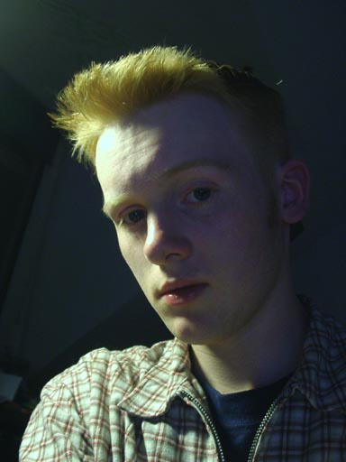

Today we have about two million people playing notpron, and that in about 7 months so far. For all who start it now; this is not one of these riddles where you click through in some minutes.... and there you go. NO! Some people spent 2 months on it. Some only needed 2 weeks. They are probably just unemployed or something, I don’t know. :)
It will take you some levels to get into this, around level 7 or 8 you’ll get a feeling for it, and you should be addicted when you got there. The best way to do it is in a group of 3-5 people or so. Then it’s the most fun. And to be honest, it’s pretty much impossible for one person, because it requires so many different skills, but still most are computer based. I don’t even understand some things myself, but we’ll get to that later ;)
Some statistic info for you:
From 100% in level 1, 95% are left in level 2. Maybe 85% make it to level 3. That’s the first big problem for most, and only 65% left in level 4. It’s now slowly going down until level 8, which kills a lot of people. Maybe 25% left there. And 10% left after level 16. Then in the mid-twenties we are down to 1-2%. These will pretty much stay there for the whole riddle, until almost the end. But still only 0.015% solved the big end riddle.
No, I’m not a fat, hairy, smelly, rich guy with nothing to do. At least that’s what people thought of me before they got to see me!

To improve the stats I made the learning curve in the first levels much fairer. In the Level details there are always some rows about the changes from the old to the new version of those riddles. The learning curve change is detailed explained in the Riddle Design Guide.

Generally it’s super hard but possible to solve for everyone who is willing to learn general computer related things. And I claim this sort of riddle is unique on the whole internet (except for my main inspiration, but this is a lot different though, I’ll explain later), but I see more and more of those riddles popping up now, but to be honest I don’t like what I see.
I’ve stopped at level 81 in my riddle (18 more followed a bit later), because I felt all good ideas for riddles were used, and those new riddles I see just lack originality and fairness. It’s like watching TV, all has been done, all new shows get worse in quality every day. Hardly good concepts that work. I still hope someone will come up with a bundle of fresh new riddle stuff! Later in this write-up I’ll have a section with hints on how to design riddles on your own, fair and fun.

Sure, there are many walkthroughs and solutions out there on the net. It’s unavoidable. If you try to get one, it’s no more big deal. But that’s the best way to ruin the fun for yourself. There are those people who just have no patience, they cheat through the game in one day (some trying to impress their friends with that), they are bored of the game, don’t understand anything and I have no clue why they even do it.
The real riddlers avoid all spoilers, because the fun comes from sitting in front of your monitor for hours until you finally get to the next level. Satisfaction is at a peak there, I promise! A type of joy, the cheaters never will feel in the whole riddle!

It’s a game. Games are about having fun. So if you want to start now, listen to me and avoid all solutions. You will accidentally get there when you try to google for clues (google is required for a bunch of riddles [10% maybe]), but you can, at the first glance, see that the result you got is just from a group of people on a forum who try to solve the same riddle you are doing. So avoid that link and look for other results.
If you just are stuck, you might get some hints after trying for hours. Nothing wrong about them, they hardly take anything away from the satisfaction you get from solving a riddle. Anyway, most people who worked their way through this afterwards came to me and thanked me because they learned so much about computers. So don’t underestimate this either.

Ok, in this write-up I’m talking about the whole making off, details to every single level, people’s happy little mistakes and I’ll showcase the outtakes.
If you are still solving the riddle, avoid text about riddles you have not yet solved; I might be giving away spoilers there. I also have picture spoilers, so don’t avoid them at first.
BUT I’ll have a bold hint-section to every level. So if you are stuck, you might read those hints. Not more than that, or it might spoil it. Don’t forget to read the rules before you start.

The rules to the riddle:
-Try all to get to the next level, don’t be limited to the picture or to the browser (but don’t try to hack the server. ;))
-There are never spaces in passwords, and all are lowercase (no CAPITAL LETTERS).
-When you are in need for a username and a password you will in most cases get both at the same time. So you will not be able to say that you got the username but you are looking for the password. An exception is Level 13, but that’s it.
Usernames are not real names. You just have to find out 2 words to put in for username and password.
-Most important, don’t limit yourself to the mouse. You have a keyboard, you have other programs on your computer, you have internet (to search and download stuff).
-You should use Internet Explorer. Other browsers do not always work.
-Write down all usernames and passwords, and don’t forget to bookmark your last level (or all).
-Make up your mind about source codes.
-There is a google search bar in all levels, which require google for most people (when external knowledge is needed). Sometimes you’ll need it as well when it’s not there, but then it’s about common knowledge.
-The URL of the next level has nothing to do with the current one.

2. Development and Stories
I’ll start where I would never have thought of making something like this. There was this riddle on www.thisisnotporn.com. The sort of game, that spreads through all forums in the world within a few days. Ok, so we sat there playing this, sharing clues and stuff, slowly getting from page to page, but actually I was only able to solve one of the levels, and after I got the solutions to the other ones, I couldn’t even say that it was fair. Nothing against that game. It’s supposed to be a big mystery, and that’s what it is. Very creepy and scary!

But there I got the idea. I’m a person, who always thinks about making/creating stuff. Whilst playing always looking for things that could be done better. I’m more a maker than a player. A game designer by heart who despises all kind of unfairness in games (I could fill books about this...).
Thisisnotporn is not that type of game that tries to be fair, so that’s totally ok.
It really got me fascinated. But every minute I “played” it (“playing” as in “reading-fake-hints-and-staring-at-the-monitor-without-a-clue”) I more wanted to make one myself. But I thought this concept could be made into something funny and fair. I would have started immediately, but I had no clue about the password box stuff. I’m no coder, really!
Ok, I asked around on the www.deathball.net forums if anyone wanted to help me. Interest was like...surprisingly low.... but there are many guys. Well took me 2 or 3 days to get someone. Coaster, a Deathball player, finally let himself down to help little David with his crazy idea! There we started. I wanted to make an easy start, for the gamers to get a feeling for this. Imagine a hard riddle on Level1. Nobody would play it, they wouldn’t even know what this is about, that there is a way to proceed! So there is a door that’s shouting: “open me”. Click the knob and you see Level 2 opening. Gives you a feeling like: “oh cool, I reached Level 2”.

Starting with something hard is totally discouraging, and people don’t go on trying.
I was at my fiancée’s home when I started this, so I needed a pic and just took some pics in her apartment. I have basically just random pictures throughout the whole riddle. Not all though. To make it look scary enough I over saturated it and changed the hue (so it’s blue and pixely, yay!).

From my years of level design experience I knew that pitched down sounds sound pretty damn scary. So that’s what I did. I remember I accidentally pitched down an Elvis performance once. Girls screaming, pitched down by 3 octaves or so.... sounds like howling wolfs. So I dug out that Suspicious Minds recording from 1970 again, took the first 2 seconds and pitched it down a lot. Got my howling wolfs again! So now you listen to Elvis in most of the riddles, you didn’t know he was that scary!

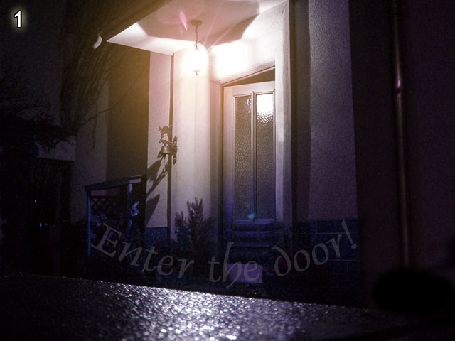
This write-up assumes that you know the solutions to all riddles. But in the end you can find the walkthrough with all solutions and hints explained, all Easter eggs discovered as well.

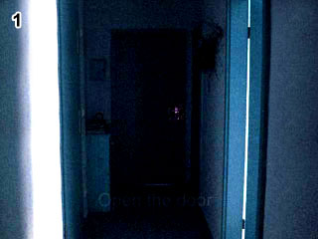
Level 1 Hints: If this level is too hard, give up and go kill yourself. No don’t!
Just read the text in the picture and just click that part in the picture…

In the beginning we had the pictures all in the same folder called, screen1.jpg, screen2.jpg etc.. Some players could see Level 9 without being close to it. But that was fixed quickly! Now it’s still the same with the sound files, you might hear the music from Level 10 in Level 8, but that’s OK.

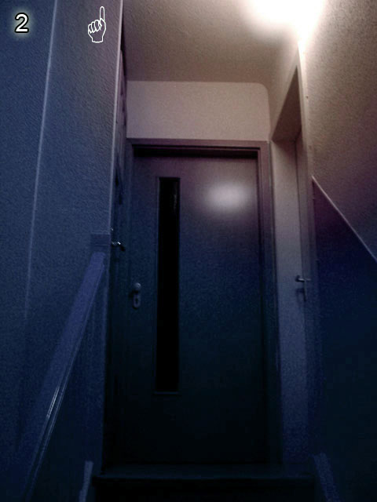

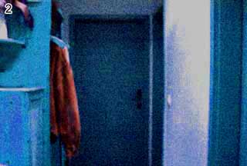
Level 2
Hints: The pop-up is telling you to trick it. Maybe use something else other than your mouse to get rid of it, so you get the link that it is hiding!
“Cool, another door, lets click it...oh, doesn’t work, must be a bug!” No, it’s not! :)
The idea for Level 2 was an accident. I wanted Coaster to make a spot in a picture, which would show some text in the status bar of the browser. It’s just a way to show a hint when you hover over it with the mouse pointer. After that didn’t work he made a pop-up that shows the text... ugh, that’s not what I wanted. And the pop-up only seemed to work with a link below it. So the first
thing I did when he gave me the HTM file was to hover over it, needed to get rid of the pop-up to reach the link below it. Being used to the mechanics of a computer, I pressed the pop-up away with the space bar and clicked the link without moving the mouse again. And I thought: “cool, could actually be a level! Difficult enough!” At first we had text showing in the status bar when you hovered over the basket on the left: “he ENTERED the new world”. But that confused people to death. The basket also showed a link (cursor turns into a hand, you know), but it was just an anchor, so nothing happened. Well we got rid of that one, and I made a gif that flashes the text every X seconds, makes it a bit more creepy. :)

The new version of this riddle is suggesting to change the address bar. I did this, because it’s a major flaw to have 2 click-riddles in the start. Because when you click 2 times, you will try to click in the 3rd riddle as well. So you are now told to change the address bar in 3. I also made it an obvious htm file (level2.htm -> level3.htm).

A general thing, try to put “old” in front of the filename of the level-pics. In many cases you get the old version then. So oldscreen1.jpg instead of screen1.jpg for example.

Level 3
Hints: Stop trying to click something, there is nothing! Read the address carefully. What can be less negative?

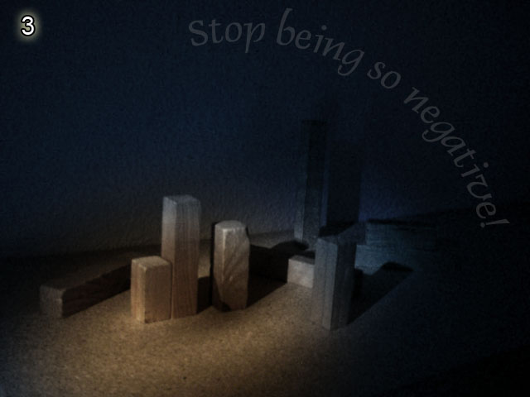
Ok, I knew it was time to do something different. Enough clicking! Now the guys needed a serious nut to crack. So the only different thing to proceed I could do, was the change of a URL. In the 3rd screen of Thisisnotporn.com you need to change an URL as well, but it is rather unfair; at least for people who are new to this, because it is super advanced. So I wanted something easy. A change from false to true is just all right for this. I got the idea for this level the previous night, before I fell asleep. I remembered that song “Du bist immer so negativ“ (Jürgen von der Lippe, my favourite German Comedian). Somehow I had the idea to take a picture of that song as a hint…. but how? Well, the only way I knew was to show a Winamp play list. Not just a screenshot. That wouldn’t be very creepy! So I just put it in the corner of the picture, on the monitor. It’s funny how every English speaking person can immediately translate the name of the song! Ok, now the song accuses you of being negative. I needed something to tell you to stop that, so the title of the page is just “Stop that”.
Already enough of a hint, but like in Level 2 we had “turn me on dead man” as text on the status bar when you moved over the monitor power button. Bad idea, because it just makes people click on that button forever, to no effect!
I just recently made the “it’s not a point and click thing” text on the bottom of the page bold, so people finally notice it and stop trying to click something! Anyway, we took the fake link from the button, and I made a gif, like in Level 2, flashing text that contains the hint. Still, I regret having the button there in the picture. People see “turn me on” and want to turn on the monitor! Argh! But not too many people get lost on this level (getting lost = give up).

The new version gets rid of many confusing hints. “Turn me on dead man” was useless. The main hint to stop being negative was not obvious enough. So I made it just say “stop being so negative” now. Just the problem is that this is the flashing text. And the button is finally gone, so people stop trying to click that.


Level 4
Hints: Is anything dark here? Light it maybe? How? Got programs for that? Do you see something now? What sort of code could it be? When you have it, press the clock.
“I don’t fucking know Morse!!!”
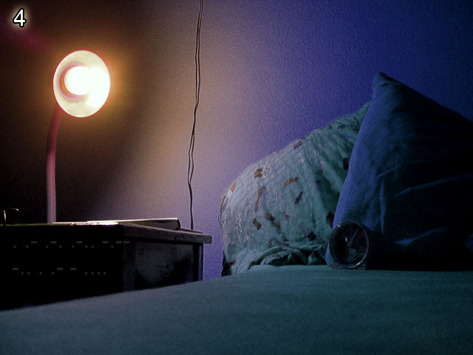
Next step, something hidden in a pic. I wanted to introduce the use of external programs here. So needed a good hint for people to brighten the pic. I have this CD from a Neo Swing band (Atomic Fireballs) called “Torch this place”. Sounded like a good hint. In the end it wasn’t. People saw the link to level 5. It includes google. So all looked for “torch this place” on google, not knowing the rule that says, that the URL of the next level has nothing to do with the current one. Too bad! Anyway, people did read through the band’s lyrics and stuff. Interpreting the wildest things into their songs, not getting anywhere. Ok, next try: I changed the text to “the fireballs got him off the right path” (him being someone who did the riddle before you, you’ll find more of those mentionings of “him”) to no avail, people looked even more for the fireballs. Argh!!! Ok, I ended up with “light this place” as password hint (the text you see in the password box) and “his torch extinguished” as text below the picture. That seems to work, and most people interpret it the right way (light up the picture in some program). But some are still too limited and want to click and do easy things. It’s hard getting people to a point where they accept that these riddles need work to be done. Most people have an attitude at this point where they want to just click through that thing and forget it forever. Still too lazy to do anything. But I think I found an ok way to slowly ‘drag’ up people to the right level of thinking. But not anyone’s fault. Being in level 2 you can’t imagine that later in level 72 you will spend 2 days or so, without getting bored!
Another funny phenomenon is that people find the Morse code. They actually know it’s Morse, and I think they are still aware of being on the Internet (where no question stays unanswered in times of google), but they honestly say: “Morse code? Wtf? I dunno Morse!”. It’s masses of people saying that! Or they are still too lazy to google for a Morse-abc. I don’t know!
The Level 4 picture really means nothing, except for it being dark and to hide the Morse code.
Some people still don’t know what this is all about. They think you need to register at www.deathball.net to enter username + password, or they randomly throw in words they see in the password box. Well, what can I do? These are those, who don’t even read the rules. Can’t help it, they deserve to get lost that early in the riddle I guess. Though I would like all to get through and have fun with it, but it seems impossible!
Again not only related to Level 4, but it’s always fun when smart-asses ask why “help/doom” isn’t working as username/password combination on Level 4. For new people: this was the old password combination, they have all been changed once to stop cheaters (well, just like the guys who ask this). So they google for the solution (no challenge, really) and come to me and say: “I found out help/doom, but it isn’t working”.... It’s so funny how they talk about having found out about it. Oh yeah! I just say “stop cheating, there is no way to find these words in the riddle”. “Cheating? What you mean? I don’t cheat!”
Blah blah blah.... It’s the same every time. I had like 1 out of 200 people admitting that they cheated. The others just leave, being pissed! Hehe, well I have some serious fun there!

Once a smart person asked: “I found what to DO on level 4. Now I just
Have to figure out how to get the damn pass and username????” Oh right!

The new version of Level 4 is no more hiding the Morse code that much. It’s pretty good viewable on all systems now. I also put in Google search bars in all levels that require it.

“I know the answer to the 4th page is Brian Setzer, but can't get a working login/pass combination... I'll try the morse code painted on the side instead.”
Huh? Don’t ask….
Probably he read something about Big Bad Voodoo Daddy (Level5) in a walkthrough and confused them with Brian Setzer, since both are responsible for the 90’s Swing Revival.

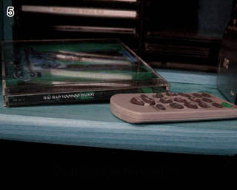


Level 5
Hints: Carefully read the URL. There are at least 2 things that can help you.
Found the right thing in google? Stop thinking too difficult, just need 2 words for Username/Password!

The idea for that one was to re-use old knowledge you just gained, and combine it with the new google element, which turns out to be important throughout the riddle. But still, the main philosophy of the whole riddle is, to make every level to be totally different from the other ones. You’ll hardly find anything that can be solved in the same way. Sure, some elements are the same here and there. But stuff that makes a whole riddle in the beginning is just a little step in the later levels, which is not even worth talking about at that state then. Like now it’s something special to check the source code, later it’s a shame not to look at it. Or editing pictures in Photoshop or so becomes a normal routine as well, which isn’t worth mentioning later. Ok, I just wanted people to google for something easy, which brings clear and obvious results. So a song lyric does the job. A song that name consists of 2 words. Big Bad Voodoo Daddy’s Cover of “Minnie the Moocher” was the one. The hint to use google sure comes from the URL. And you have a line in the URL (the .htm part), which makes a sentence, a part of the lyrics. Google for it and you got the answer. At the bottom of the picture, when you brighten it, you get another one, which is not needed though. In the source I had a hint like this “<!--“username” the “password”--> which I thought was super obvious. But I had fun listening to people who had the song name (Minnie the Moocher) and still couldn’t make anything out of it when they saw “username” the “password”. If that hurt, some people would be dead by now! Well, same as in Level 4, Minnie the Moocher is the old password combination, so some people still come asking me why minnie/moocher isn’t working. Ahem.... well! It was then changed to another song, and thereby I fixed the problem, that Minnie the Moocher isn’t on the CD that can be seen in the pic. It was the previous album. Well the new song is on this album.

The new version of Level 5 is now actually asking for the name of the song, which was a bit unfair in the old version because you were missing a basic guideline.

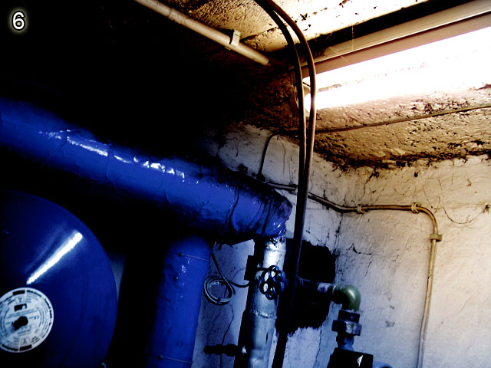

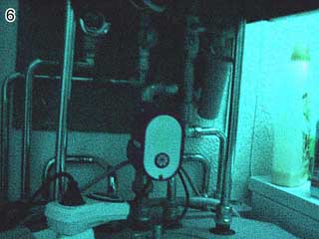
Level 6
Hints: Make up your mind about the source code!

Again a super pointless picture. I just ran through the house, looking for things to take pics of. Only important thing about this is, that it doesn’t show text, and I didn’t want it to show people. Sure, text confuses people to death. Every word can be interpreted as a weird hint, but it maybe doesn’t mean a thing. No good! The idea was this level was, that I found it funny to sit in front of a pic for hours, you start randomly clicking stuff on your screen (do you know it when you start dragging boxes on your desktop when you are bored?) and then you suddenly click this hidden text down there. A bunch of numbers, what the hell? Well, it was time to introduce the source code finally. It’s still not necessary, but most people seem to find the hidden numbers through the source code, where you can access another file that includes them. The numbers should tell everyone something, who’s a slight geek. If you aren’t, this is the end for you, bye bye ;) But for those who aren’t that smart yet, I added the “ALTernative” hint. You know, hold ALT pressed and enter some numbers in the num-block, that way you can produce any character available.
But only ASCII would be boring, so I scrambled it, and added “mixed up” as password hint. “hsattti” was the word all came up with. “Why isn’t hsatt/ti working?” Because it’s mixed up, and those 2 aren’t proper words, that’s why! After the password overhaul it was changed to phel/mood .... which people still just try to enter that way, and then come complaint to me that it’s buggy. Oh and some people still moan that “thats/it” isn’t working. Well, cheaters, go to hell, will you? “mixed up” was changed to “anagram” in the password hint, because I just found out about this word, I didn’t know that there even was one. By the way, what I said about text in pictures not being good, here it applied! See the bottle on the right? Some freaks deciphered the name of it and came to tell me, that they use the same at home. And for sure, it was worth trying the name as password or so....*cough* ;) Well you do weird things, when you are desperate. Too bad I have no list of what people enter as wrong passwords. That would provide some serious entertainment!
Some people saw the sdrawkcab folder of the next riddle and thought they’d be super smart to enter “phel/mood” the wrong way around. Still missing the rule about the next URL not having anything to do with the current level.
The picture is just a boiler, no meaning :)
My all-time favourite fuckup is the following, I’ll start quoting from the point where he found the numbers:
“I got a string of numbers. I google searched for those, and found that someone had tried to put them into binary. SO I tried that. :) I went from decimal to binary, and from binary to ASCII, and got a band name (NIN) and a number (4). Nine Inch Nails is an alternative band, so this might be the right path... or it might not. ;) I'm trying every combination of the band name, album name, band members, etc that I can think of”
Yay, soooo close...to nothing! Or what about this:
"At level six, I think u just need to press alt, but it doesn’t work :("

The new version of Level 6 is a bit easier. The box with the hidden ASCII code is a LOT bigger now, and I added a hint towards ASCII (well hint as in saying, that it’s ASCII in the source code), and the new title hints you to check the source code. This is all for the beginner friendliness. After all you are here to learn something as well. But if you get to 6 without knowing ASCII, you were lost. Also the source code was never introduced before. So my new goal is to drag bloody noobs as high as possible. :)
Not telling them the answers, but I’m aiming for a lot flatter learning curve. It was too drastic before.

Here a way to solve the old version (“thats it” as u/p):
“Ok, now I’m on level 6.... and wtf is indeed here... heh, I found something.... if you highlight near the bottom right, you get the numbers
104 115 097 116 116
116 105
and when you put them into an ASCII converter, you get
00110001 00110000 00110100 00100000 00110001 00110001 00110101 00100000 00110000 00111001 00110111 00100000 00110001 00110001 00110110 00100000 00110001 00110001 00110110 00001101 00001010 00110001 00110001 00110110 00100000 00110001 00110000 00110101
can anyone read computer language? yeah that is in base2. all computers use it, try converting to base 10 (the standard base) or binary to get ummm something else”

You see this level has a big potential for jerks to get some attention with stupid ideas, one more *cough*… Level 6 or 7?
* De1337 has joined #notpron
<De1337> I don’t get #6
<De1337> help?
<thisthing> think outside the pic ;P
<De1337> I checked the source and I saw the Twix candy wrapper
<thisthing> oh isn’t that level 7?
<thisthing> not 6
<De1337> level 6
<De1337> its 6
<DavidM> uhm?
<DavidM> you make no sense
<De1337> ok
<DavidM> or did you read too many walkthroughs
<thisthing> lol
<DavidM> Twix is in 7
<De1337> it says "an ALTernitive"
<thisthing> yeah there's no Twix there
<De1337> there is a Twix wrapper to the right side. well it looks like one
<DavidM> you are lying
<DavidM> you read it on some forum or a walkthrough or something. this is bullshit
<De1337> no I am not
<thisthing> there’s nothing that resembles Twix in 6
<DavidM> only some flawed solution maybe: D
<De1337> wtf? I haven’t read any walkthroughs...i got #notpron form the source on the website
<DavidM> give it up. There is no Twix indication on #6
<DavidM> just admit it, it’s annoying
<De1337> I’m not lying
<DavidM> -_-
<DavidM> sure you aren’t.....you sure see a Twix wrapper on the right
<De1337> it looks like a bottle but has the Twix looking wrapper on the side
<DavidM> he has x-ray eyes, he can look through 6, down to 7
<DavidM> its funny how the cheaters never admit it :D
<De1337> I’m not positive its a TWIX wrapper but that’s what it looks like
<NEIGH> Hehe
<De1337> dude stfu.. I don’t have a walkthrough
<DavidM> well, you are lying about seeing the Twix on 6 :)
<De1337> why do you think I’m in here?
<NEIGH> when you're going to use a walkthrough to cheat on a level, make sure you are on the right level
<DavidM> LOL
<De1337> omfg ....what do you see on level 6?
<DavidM> we don’t see the Twix from level 7
<De1337> then wtf am I supposed to do on level 6?
<De1337> cause I’m not on level 7
<DavidM> you are seriously entertaining....this will be good fun for the book
<thisthing> well, if u want to get past 6, forget about Twix
<DavidM> Go back to Level 5 to see the solution to #6 then

...bit later...

<De1337> I’m on # 7 now too
<DavidM> and now you see a guitar?
<TMD> lol shh David
<DavidM> :D

A lot more to come in the full version!

To be gotten at: www.notpron.com

3. Riddle Design Guide – Planning to do your own riddle? No tutorial, but some guidelines to keep it fair and interesting; including examples on how not to do it!

Many got some inspiration to do their own riddle from this, like I got my inspiration from another similar thing, and many notpron players already made their own riddles. But unfortunately all who tried their stuff didn’t like any of them, except a few single ideas maybe. There’s really not a single series of riddles that really does it to me and the main problem I see is unfairness! But I try to change this circumstance by writing this. Because I finally want to riddle myself, which I hardly did. Stop calling me smart, I’d probably get stuck in my own riddle in the 40’s or 50’s, don’t really know. Making these things is a creative performance, not much intelligence required. The riddlers do the thinking, not the maker. :)
Fortunately I got a good start with the riddle, due to my years of experience in Game and Level design. I never did something like this before, but everything I do is different from the previous project, so I am used to doing new things and thinking into new gameplay mechanics. And whenever I play something (no matter if shooter, adventure or even watching a movie) I keep analysing the way it was made, the gameplay mechanics, camera moves, whatever. But it helps a lot when I do these things on my own then. I can only recommend it, although it increased my expectations to Games, Movies, Music a lot, and all who know me, know that I’m Mister Moan, complaining about everything that’s not perfect. Only the best for Mister M. But criticising everything helps getting better a lot, if you have the same expectations to yourself than you have to others.
However, I’ll start with the main concern. I hope I can introduce you to the right way of thinking to make a riddle.

A-Z
Let me explain it this way: When you design a riddle you think through it from A to Z, but once you play it, you think from Z to A. So think both ways every time.
For example, you want to hint to something, which I call A. When you think of it, B comes to mind. So you use B as a hint to A. But unfortunately when thinking of B there is no way you think about A.
To make my thought more obvious, here an anti-example that someone submitted to me. A simple change of the level image from night.jpg to day.jpg. Experienced riddlers don’t even think about it and always try opposites and series (pic1, pic2 etc.). But just for the case you want to hint to this file change. That guy’s way to do it was in the title: “big mouse” and the filename was “opp.htm”.
“Big mouse” and “opp” as opposite. You’d never ever know what these 2 things are supposed to mean. You see that a “big mouse” is a contradiction in itself, but there is no relation to the image name. (A mouse can be big though, a sad clown or so would fit better, but it sucks anyway ;)).
From “opposite” you might get to “opp”, but not the other way around. And once again, there is no relation between opposite and the picture, although it would be clearer in this case, because there is not much else other than the picture. Just the “opp” thing gives you no clue. The filename should just say “opposite”. That would give you some options! And the “big mouse” hint is not giving you the “opposite” idea.
When you think of an opposite, “big mouse” comes to mind, but when you see “big mouse” you don’t think of an opposite. Read it slowly to understand it, otherwise it gets confusing and you can’t follow.
You design it from A to Z, and the player thinks through it from Z to A
I hope you get what I mean. This is one of the most important things in my opinion!

Another example can be found in the description to 39. The old way it was intended by the maker was totally the wrong way. Got read it to get a clue.

A lot more to come in the full version!
To be gotten at: www.notpron.com

4. Quotes and stuff – Funny, stupid, smart quotes from riddlers and other talking.
I’ll just randomly list all quotes I have on my list ;) (every empty line is a new one)

please stop making new levels at least till 11th of Feb. ‘cause I can't stop from solving them and because of that
I can't learn and if it goes on I won't pass my session and my parents will kill if I don't

LOL, that’s the cool thing about this riddle. Never think you understand the way it works. You’ll be surprised all the time.

I put in the right username and password but there was an error. It said "Authorization Required". How do you get to the next level then???

What is pron?

Head meets desk at this one: "Can someone give me the URL for 15? my computer can't do the accent thing on deja in 14 so I can't move on?" Ouch!! (you might need a few seconds to actually understand this one ;))

How to identify a noob "weeeee I just wasted 10 min's of my life..."
The pros waste days and weeks, dammit!!

What made this riddle so fascinating is that it took a whole butt load of skills to complete. You needed to be aware of computer functions such as how to find that sound program in system32 folder (which I didn't even know was there), decipher maths and codes using hex, ASCII, and binary, you needed to learn a little about music, know how to Photoshop, how to hunt, how to do word scrambles, anagrams and such, learn foreign languages, make an origami number figure, and learn how to cheat at minesweeper (which I didn't know was possible). Usually people are good at one or two of those things, but you had to get good at them all to succeed.

Your riddle taught me many ways to see problems and to find solutions.

<NEIGH_80> why do so many pictures end in “tbh”
<DavidM> to be honest they are good pictures
<DavidM> no, just random

<Grew> must say: best riddle in the world

Ok I understand the jist of the game with the URL and everything but what do you do for level 3. Hints
anyone? I think you check the URL or click randomly, but hell what do I know, I am on level 2

A lot more to come in the full version!
To be gotten at: www.notpron.com

5. Thanks to …

… Junimond for all the support with the book, for reading this thing over and over and for encouraging me with whatever I do.
… Triper for her technical Word Help (sorry, this is the first time that I actually use wrote something like this)
… Susi for existing and being the coolest person I’ve ever met! I <3 U
… All riddle submitters, without them the riddle would only be half of what it is now. Especially Helena of course! And thank you guys for writing the stuff for the book!
… whoever I might have forgotten!
… all people who donated a few bucks (or more)! Really appreciated, thanks a lot!
… and of course all loyal riddlers. Without your constant begging for new levels, Notpron would end at Level 23 I guess!

6. Walkthrough

Hello dear walkthrough lamer! ;)  Official notpron walkthrough;  Rest in pieces if you publish it!  Also check www.notpron.com for the "Making of" book!  ~~~~~~~~~~~~~~~~~~~~~~~~~~~~~~~~~~~~~~~~~~~~~  1. www.deathball.net/notpron/levelone.htm  -Click the door to proceed  Eggs:  change "notpron" to "pron"  ~~~~~~~~~~~~~~~~~~~~~~~~~~~~~~~~~~~~~~~~~~~~~  2. http://deathball.net/notpron/not/level2.htm  -move the mouse on the door handle,  use enter to click the popup away,  click with the mouse on the handle,  now that you tricked the popup.  Or get the next link from the source code  Or be faster than the popup (on slow machines)  Or turn off Java Script, so the popup won't come up.  Or change "level2" to "level3" in the URL (the pic is sorta asking to change the address, and it's pointing at  it with the hand)  ~~~~~~~~~~~~~~~~~~~~~~~~~~~~~~~~~~~~~~~~~~~~~  3. http://deathball.net/notpron/false/gototheothersite.htm  -You can see "Stop being so negative!" flashing.  -"Turn me ON" is the title  Turn "false" in the url to "true"  (hint in source telling you to read the whole url, because most only read the htm part)  Eggs:  change "false" to "right"  change gototheotherside.htm to positive.htm and to negative.htm  ~~~~~~~~~~~~~~~~~~~~~~~~~~~~~~~~~~~~~~~~~~~~~  4. http://deathball.net/notpron/true/gototheothersite.htm  -Look in the dark  -light the place = brighten the pic, you'll find a morse code hidden on the left, on the table.  translate it and you get username (top) and password (bottom line)  this would be username and password  ~~~~~~~~~~~~~~~~~~~~~~~~~~~~~~~~~~~~~~~~~~~~~  5. http://deathball.net/notpron/google/ifyourloveshouldfail.htm  url = if your love should fail  red button asks for password and reveals hint: beatiful life  Still got your torch lit? Meaning: brightening pic reveals "on the 8th of november"  Url mentionings google. Google for these quotes all get you to one song that consists of 2 words (username and  password)  ~~~~~~~~~~~~~~~~~~~~~~~~~~~~~~~~~~~~~~~~~~~~~  6. http://deathball.net/notpron/nothing/hesgotitall.htm  ...the source code might help...  look down, there is hidden stuff:  112 104 101 108  109 111 111 100  an ALTernative for it?  hold ALT pressed, press 1 0 4 and release ALT. getting you this: h  do this for all numbers  phel  mood  Scramble both to get username and password  Click the middle circle thing to get it.  Eggs:  -change "nothing" to "all" or "everything" in the URL  -change "hesgotitall" to "hesgotnothing" in the URL | ~~~~~~~~~~~~~~~~~~~~~~~~~~~~~~~~~~~~~~~~~~~~~  7. http://deathball.net/notpron/sdrawkcab/tieman.htm  URL: sdrwakcab = backwards  tieman = nameit  name the wrapper you see, its twix.  In the title (old school) and in the webpage source you get a hint that times have changed in deutschland.  It used to be called "raider" in germany.  Tho it has to be mirrored to proceed.  Eggs:  -put it twix or xiwt or raider or redair or rider, or raiders, nameit  -/backwards/tieman.htm (and nameit.htm, twix and xiwt)  A lot more to come in the full version!  To be gotten at: www.notpron.com

All rights reserved; no part of this publication may be reproduced or transmitted by any means, electronic, mechanical, photocopying or otherwise, without the prior permission of the publisher

First published in Germany in 2005

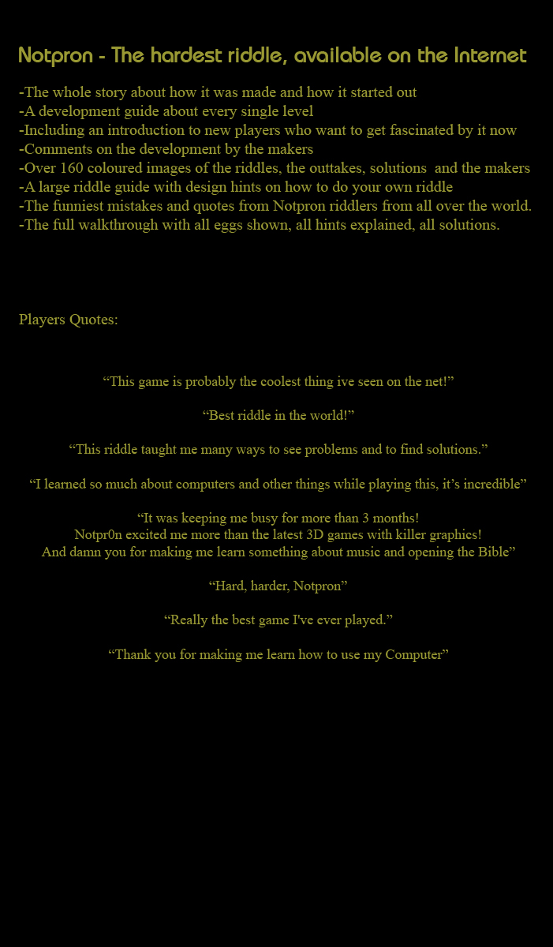
Copyright © 2005 by David Münnich

